
667 George Moretz Lane
Boone, NC 28607
828-265-0198
csmalling@audubon.org
www.ncaudubon.org

November 15, 2011

Chief Clerk
N.C. Utilities Commission
4325 Mail Service Center
Raleigh, NC 27699-4325
Project: PANTEGO WIND ENERGY, LLC (EMP-61)

To Whom It May Concern,

Please accept the attached comments on the Application for a Certificate of Public Convenience and Necessity to Construct a Wind Facility of up to 80MW & Petition for Registration Statement dated 09/02/2011 (Docket No. EMP-61 Sub 0). We are concerned that any project with the potential to impact this many birds in or near one of our Important Bird Areas needs to show extremely high due diligence in pre-construction study, mitigation and adaptive management plans, and willingness to share data and issues in an open way including post construction operation and monitoring.

As you can see from our comments, there are many issues associated with construction of a wind facility in this sensitive area and the original documents filed with the Commission by Pantego Wind do not adequately address many of these concerns. We support the request by the various state agencies responding to the clearinghouse request for comment (filed with the commission on 10/21/2011) that data in the application are insufficient for their determination of impact and concur with their request to delay an official ruling by the Utilities Commission until such time as those regulatory agencies are satisfied with the information provided.

Thank you for your time and attention to his matter.

Sincerely,
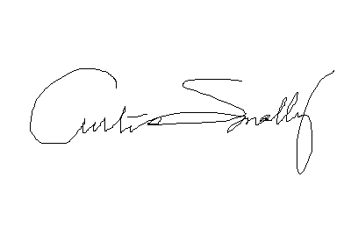
Curtis Smalling
Important Bird Areas Coordinator and Mountain Program Manager
Audubon North Carolina

Pantego Wind Project Comments

Overview
Both the National Audubon Society and Audubon North Carolina have adopted wind energy policy statements that support the development of responsibly sited wind energy projects in the United States and North Carolina. These policy statements are available at www.ncaudubon.org.
Commercial wind has the potential to have impacts on birds through direct mortality (collisions), habitat loss from construction and connection to the electrical grid, habitat exclusion as birds avoid areas with turbines (which can reduce available breeding, foraging, or migratory habitats and pathways, and the cumulative effects of these factors at a landscape scale (wind resources tend to be clustered near certain geographic features like ridge lines or coast lines and so projects also tend to be clustered in these areas).
The current proposal from Invenergy Wind North America LLC (dba Pantego Wind Energy LLC) is to construct a commercial wind development in Beaufort County, North Carolina encompassing some 11,000 acres in a generally northwest direction from Pantego. The project would include approximately 49 turbines capable of generating about 80 megawatts of power. Construction is anticipated to begin in 2012 with production of electricity beginning in late 2012. Full details from Invenergy’s Application for Public Convenience and Necessity before the Utilities Commission are available on-line and are referenced as Docket EMP-61 Sub 0 (available for review at http://ncuc.commerce.state.nc.us/cgi-bin/fldrdocs.ndm/INPUT?compdesc=PANTEGO%20WIND%20ENERGY%2C%20LLC&numret=001&comptype=EMP&docknumb=61&suffix1=&subNumb=0&suffix2=&parm1=000136331.

Project Evaluation – each proposed commercial project is evaluated on the following 5 criteria as they relate to birds
- Proximity to IBAs – is the project within an IBA? If not, does it include critical foraging habitat adjacent to an IBA? Does it lie between IBAs that share birds? (An example might be Pocosin Lakes and Mattamuskeet that often have daily movements of wintering waterfowl.)
- Habitat Loss – will the project result in a loss of habitat, either for breeding, migration, or wintering? Is there a plan in place to mitigate those losses?
- Habitat Exclusion – will the project exclude suitable habitat from breeding, foraging, or roosting habitat due to habituation, avoidance, or disturbance of priority species? Is there a plan for mitigation of this effect?
- Rigor of Data Collection and Analysis – does the project make a thorough use of existing data? What are the species present and their conservation ranking and relative or absolute abundance (if known)? What is the plan for pre and post construction study and monitoring? Does it conform to widely used methods and best practices? Does the study plan cover the entire annual cycle of birds in the project area? Is that study based on the USFWS voluntary guidelines for siting study and evaluation or near equivalent? Is that data open and available for outside review and evaluation, especially post construction, so that future projects can learn from existing projects?
- Cumulative Impacts – what are the suspected cumulative impacts from the project on bird populations, habitat availability, connectivity, etc? Are there plans for expansion of the project in later years should it prove economically viable?

Proximity to IBAs –

The Pantego Wind Project lies partially within Audubon’s Pungo-Pocosin Lakes IBA (figure 1). This area supports thousands of wintering waterfowl including a high percentage of the eastern United States population of Tundra Swans (Cygnus columbianus), many other species of waterfowl, raptors and other species (Golder and Smalling, 2011). It is located in the southwest corner of this IBA and includes areas normally used for foraging flights of wintering waterfowl, wintering blackbird flocks, and additional species of concern. The project area was identified as critical foraging habitat for wintering waterfowl during the analysis done for the Outlying Landing Field lawsuit. Much of the area west of Pocosin Lakes National Wildlife Refuge is heavily used by wintering waterfowl, especially Tundra Swans and Snow Geese (Chen cearulescens). These uses typically occur as daily foraging flights from roost sites in the area to foraging sites in stubble or winter wheat fields.

In a study of bird usage in agricultural fields on the Albemarle-Pamlico peninsula in 2003 (Smalling, unpublished data), bird usage was higher than anticipated, but still differed significantly from a reference site that included managed impoundments and natural wetlands (about one fourth of the total number of birds per point but still very high at over 340 birds per 10 minute count.) The agricultural lands also hosted a significant number of species (98 species versus 128 on the reference site). The top ten most common species encountered in that study accounted for almost 90% of all detections and included most species of blackbird [Red-winged Blackbird (Agelaius phoeniceus) , Brown-headed Cowbird (Molothrus ater), Common Grackle (Quiscalus quiscula)], and other species like Snow Geese, Trees Swallows (Tachycineta bicolor), Ring-billed Gulls (Larus delawarensis), and Dunlin (Calidris alpina).

An important factor in evaluating the bird usage of an area is the species using the air space that includes the rotor swept area. In the study referenced above by Smalling (2003), over half of the species encountered used the air space including the rotor swept area. Certain taxonomic groups used these heights more frequently than others and this group included waterfowl, shorebirds, raptors, and gulls. Large blackbird and European Starling (Sturnus vulgaris) flocks also occasionally moved through these heights as well.

The literature reveals an apparent disconnect between high rates of usage by waterfowl and direct mortality however. In areas with high concentrations of waterfowl, mortality has been quite low compared to the number of birds in the area (Erickson et al. 2002; Kingsley & Whittam 2005).

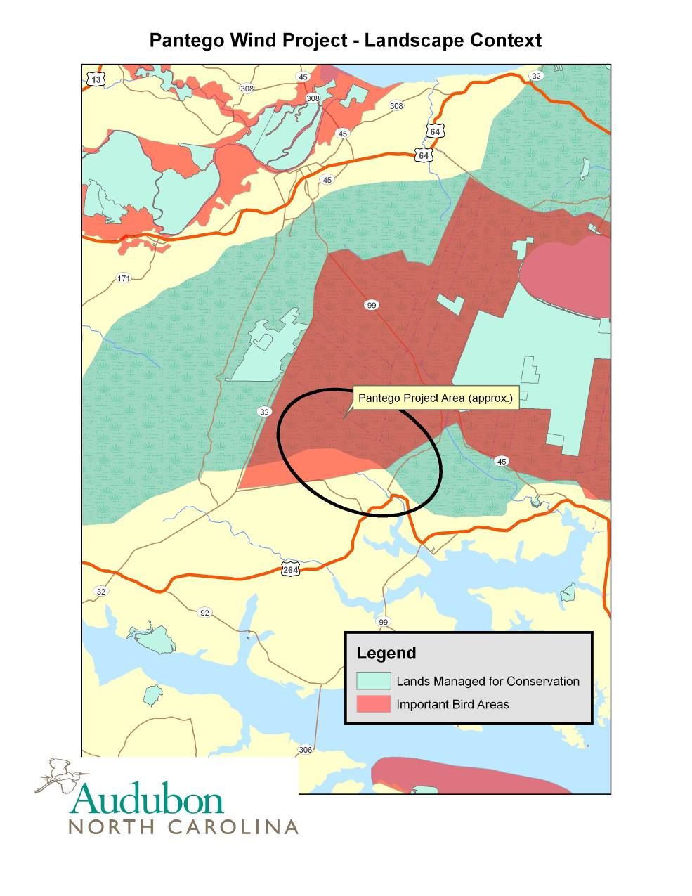

Figure 1 – Local Landscape Context of the Pantego Wind Development

While there are tens of thousands of individual waterfowl in the area, past studies across the United States and elsewhere have shown little direct mortality impacts to waterfowl as a group (Kingsley and Whittum, 2005; National Academy of Sciences, 2007). This is thought to be due to habituation and detection of turbine fields (Pettersson, 2011), but on a broad scale, could also be attributable to a lack of turbines in high quality waterfowl habitats. Figure 2 below summarizes mortality by guild of bird species and region of the United States. As more projects are built in and adjacent to heavily used wetland areas and waterfowl foraging sites, those percentages may change. A hint of that is already visible in the increased percentage of fatalities in the Midwest (about 6%) compared to other regions (about 2%) as some projects in the upper Midwest are in areas utilized by more waterfowl. (More problematic than direct mortality is the exclusion of foraging areas from productive use by these wintering species. This is discussed more fully below in the habitat exclusion summary.)

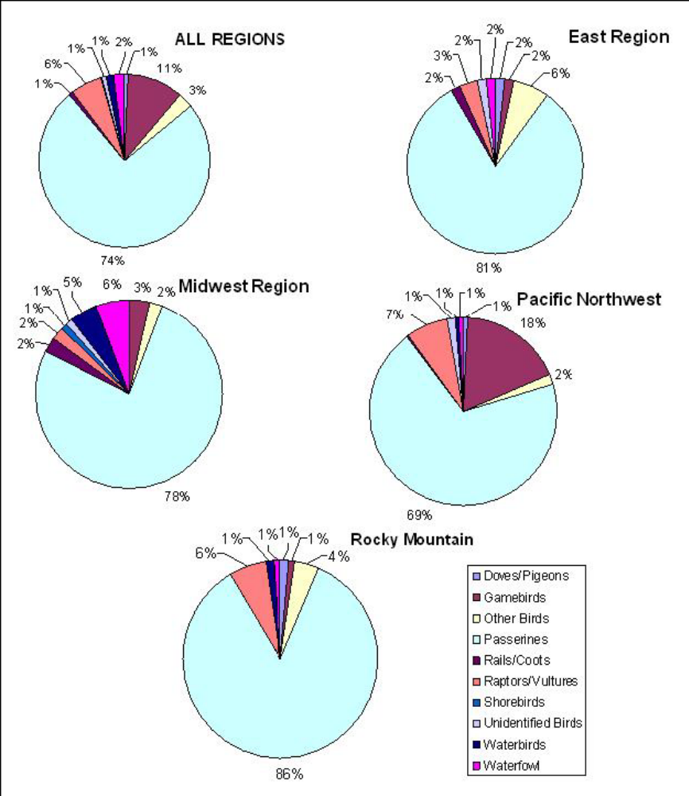

FIGURE 2 From National Academy of Sciences Report 2007, p. 56
Composition of bird fatalities at 14 wind-energy facilities in the United States.
Sources: Compiled by committee from Erickson et al. 2000, 2003b, 2004; Young et al. 2001, 2003b, 2005; Howe et al. 2002; Johnson et al. 2002, 2003b; Nicholson 2003; Kerns and Kerlinger 2004; Koford et al. 2004.

While wintering waterfowl are a primary concern at the project area, the proximity of the project area to the large open water of the Pamlico River suggests that landbird migrants may at times occur in high numbers during migratory periods. Many landbirds avoid crossing large bodies of water and so “pile up” as they wait for conducive winds to assist in crossing, or by the same token, land after crossing to rest and refuel. While we have little data from this project area, it is important to understand these dynamics, as most mortality at eastern wind energy sites have been from nocturnal migrant passerines (Strickland et al, 2011). Kunz et al (2007) provide a comprehensive overview of methods for monitoring the nocturnal usage of wind project areas by birds and bats.

Bats too are a concern and much recent research has been focused on bats in the eastern United States (Proceedings of the Wind Energy and Bird/Bat Workshop, 2004; Arnett et al, 2008; Cryan, 2008; Strickland et al, 2011);. Other research has begun to address possible mitigation and operational adaptation to lessen bat mortality, including reducing so called “cut in speed” or the wind speed required to begin power generation, which has been shown to reduce mortality by up to 60% at one site (Baerwald et al, 2009). Of possible concern in the current project area is the affinity for locally abundant bat species to forage along forest edges, which are more common in the southern edge of the project area (Morris et al, 2010). This study was conducted north of the project area near Plymouth, North Carolina and detected some species that have been common species killed at other eastern wind energy installations [Hoary Bat (Lasirius cinereus), Eastern Red Bat (Lasiurus borealis), Big Brown Bat (Eptesicus fuscus)]. Figure 3 was generated from the Southeast GAP on-line tool (available at http://basic.ncsu.edu/segap/) and is based on predicted distribution using a habitat suitability model for several species of bats including the following: Brazilian free-tailed bat (Tadarida brasiliensis); Eastern pipistrelle (Pipistrellus subflavus); Evening bat (Nycticeius humeralis); Seminole bat (Lasiurus seminolus); Northern yellow bat (Lasiurus intermedius); Eastern red bat (Lasiurus borealis); Silver-haired bat (Lasionycteris noctivagans); Big brown bat (Eptesicus fuscus); Rafinesque's big-eared bat (Corynorhinus rafinesquii).

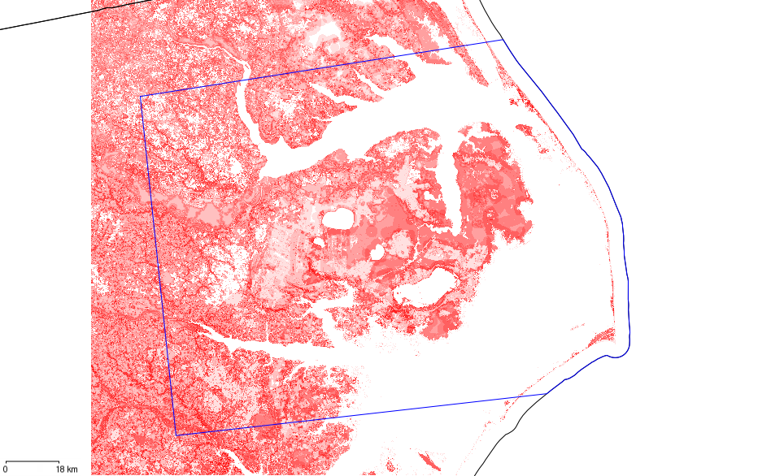
Figure 3 – Predicted Bat richness for the Albemarle Pamlico region from SE GAP on-line tool. Generated 11/15/11 using species listed above.

Habitat Loss –

This project, if constructed entirely within existing agricultural lands, will likely have minimal direct habitat loss. If mitigation is employed to reduce bird usage, some changes to farming practices might be encouraged including which crops to plant immediately adjacent to the turbine array, but agricultural activities are expected to continue in the project area. Habitat impacts should be limited to road bed improvements, turbine pad construction and grid connectivity and maintenance facilities on-site. The plan as presented in the Application for Public Convenience and Necessity shows connectivity to the existing electrical grid is indicated to be on-site and so transmission issues above ground should be minimal. During discussions with the developer on November 11, 2011, they confirmed that the 49 turbines would directly impact about one acre per turbine with a small amount of that area converted to impervious surface (a concrete pad around each turbine) and that all transmission would be underground until reaching the town of Pantego for overhead access to the substation there.

Habitat Exclusion –

Many studies suggest that waterfowl habituate or avoid turbine arrays while moving between foraging areas or during migration (Kingsley and Whittam, 2005; Pettersson, 2011). If this is the case, the large area covered by this installation could be made unavailable to foraging flocks. The literature suggests that this may vary according to species however (Powlesland, 2009). Other groups of birds (gulls, raptors, shorebirds) may be at risk as well but the literature is inconclusive at best about risk of mortality or exclusion and habituation in these other groups (Kingsley and Whittam, 2005; Powlesland, 2009). Raptors in western settings have shown mixed responses, in some cases more inclined to utilize areas with land management schemes favoring small mammal populations (Smallwood and Thelander, 2004) and habituating in others to avoid turbines (Sharp et al, 2010). There is still much to learn about other groups (gulls, shorebirds, wading birds) that regularly use these agricultural areas (Kingsley and Whittam, 2005; Brennan, et al, 2010; Blackman, 2011), although exclusion of habitats for some grasslands birds is well documented (Horton, 2010; but see Devereaux, 2008).
Much of the bird usage of the agricultural lands in the project area is directly tied to crop history, current planting regime, and soil condition (Rottenborn, 1996; Smalling, 2003). This fact leads to possibilities for mitigation off site or operational adaptive management to influence bird usage within the turbine array. Fields adjacent and within the project area could be adaptively managed to discourage use by wintering waterfowl, once detailed analysis of risk and seasonal movements are understood. Understanding the dynamics associated with private waterfowl impoundments, their seasonal flooding, and the economic impacts to hunt clubs and guide services should also be considered and incorporated into planning for the operational management of the project. Many sources provide guidance to existing approaches for a variety of adaptive management and mitigation measures (Kingsley and Whittam, 2005; Environment Canada, 2007; National Academy of Science, 2007; PNWWRM VII, 2011; Strickland et al, 2011; USFWS, 2011).

Rigor of Data Collection and Analysis –

The Application for Public Convenience and Necessity does not include details of the methods of data collection being used for pre-construction study of the Pantego project.. In preliminary discussions with the environmental consultant for Invenergy, we do know that they have been conducting diurnal surveys since late winter of this year and plan to continue surveys to complete an annual cycle survey. Additional details of the study methods and duration were made available to Audubon at a scheduled meeting with the developer and consultant on November 11th, 2011. They are currently engaged in three basic studies for birds and one for bats. The first is a diurnal point count method to evaluate species presence or absence and relative abundance. These 800 m radius counts (approximately 15-20 for the project area) are conducted approximately every other day for 30 minute periods at each point.

Invenergy contractors are also currently conducting aerial surveys for large aggregations of waterfowl and raptor and eagle use of the project area until April of 2012. They will be looking for the areas most used by large flocks of Tundra Swans and Snow Geese or other large aggregations during flights occurring at least once every two weeks.

In a third study (conducted in 2011), the developers consulting team searched for active Bald Eagle (Haliaeetus leucocephalus) and other raptor nests. Six active Bald Eagle nests were found south of the project area. Current point counts and aerial surveys are trying to determine the level of use of the project by these pairs or other wintering raptors. Invenergy staff stated that they intend to follow the steps outlined in the USFWS guidance on Eagle Conservation Plan Guidance (USFWS, 2011a). It appears that they are currently at a stage 2 review and site usage assessment using the USFWS guidance framework.

It is our recommendation that all currently available data be reviewed (including a list of sources provided by Audubon in Appendix 1 and that standard methods are used for pre- and post-construction study (USFWS, 2011b; Strickland et al, 2011). Publicly available Department of Defense materials and data prepared for the proposed outlying landing field near the project area should also be consulted and included in the analysis (Netti et al, 2007). This data includes radar, aerial surveys, and wintering waterfowl surveys for an extended period of time over several years.

It is also preferred that data sharing occur and that results of newly completed surveys not be sequestered by the developer. This is especially true of post construction monitoring data as this is the single best source to evaluate cumulative impacts, efficacy of adaptation and mitigation strategies, and operational impacts.

Cumulative Impacts

This is a difficult measurement to obtain or model given the lack of data, small number of projects, and variables present. However, basic guidance regarding cumulative impact analysis and theoretical thinking can be found in the National Academy Report on wind energy impacts (Environment Canada, 2007; National Academy of Science, 2007). In general the two factors most often considered in cumulative effects are: 1) any population level impacts of wind energy development in a specific region and the thresholds for creating a population level impact through direct mortality or lower survival rates or productivity and 2) the habitat thresholds for altering the bird communities in the region through exclusion or avoidance. While these are currently difficult to assess, there are projects underway that attempt to model these impacts (see Strickland et al, 2011).

Recommendations

- Continue to utilize the framework of the USFWS service voluntary guidance for siting of wind energy projects including Tier 5 research projects if waterfowl or eagle usage appear problematic, and to commit to adoption of a avian and bat protection plan (USFWS, 2011b).
- Continue to utilize the framework of the USFWS Draft Eagle Conservation Plan Guidance document, including completion of an eagle conservation plan for the project (USFWS, 2011a).
- All currently available data be reviewed (including a list of sources provided by Audubon in Appendix 1 and that standard methods are used for pre- and post-construction study (USFWS, 2011; Strickland et al, 2011).
- It is also preferred that data sharing occur and that results of surveys not be sequestered by the developer. This is especially true of post construction monitoring data as this is the single best source to evaluate cumulative impacts, efficacy of adaptation and mitigation strategies, and operational impacts.
- If abnormal or significant weather events occur during the survey and evaluation period (nor’easters, snowfall, etc), to monitor bird usage during and immediately after such events, even if out of the normal monitoring rotation.
- Continue to monitor bat usage of the proposed project area, and commit to adaptive strategies like changing cut-in speeds during migratory periods.
- Arrange the final turbine array as far south and west as possible within the project area.
- Establish a plan for operational adaptation to conditions on the ground which are likely to vary between and within seasons and years including disruption of generation if necessary, management of fields immediately adjacent to the turbines, and other necessary adaptive measures.
- Consider mitigation of habitat excluded from use by waterfowl, shorebirds, and other birds in the project area by supporting permanent protection and or management of additional parcels in proximity to the Pocosin lakes National Wildlife Refuge.

Literature Cited

Arnett, E. B., W. K. Brown, W. P. Erickson, J. K. Fiedler, B. L. Hamilton, T. H. Henry, A. Jain, G. D. Johnson, J. Kerns, R. R. Koford, C. P. Nicholson, T. J. O’Connell, M. D. Piorkowski, and R. D. Tankersley. 2008. Patterns of bat fatalities at wind energy facilities in North America. Journal of Wildlife Management 72:61–78.

Blackman, Emily B. 2011. American Woodcock Winter Habitat Use in an Agricultural Landscape. Master’s Thesis. North Carolina State University. Raleigh, North Carolina.

Brennan, Leonard, R. M. Perez, S. J. DeMaso, B. M. Ballard, and W. P. Kuvlesky, Jr.. 2009. Potential impacts of wind farm energy development on upland gamebirds: Questions and concerns. Pages 179-183 in Proceedings of the Fourth International Partners in Flight Conference. 13-16 February 2008.. McAllen Texas. Terrell D. Rich et al editors. Partners in Flight.

Cryan, Paul M. 2008. Mating Behavior as a possible cause of bat fatalities at wind turbines. Journal of Wildlife Management 72(3):845–849.

Devereux, C.L.; Denny, M.J.H.; Whittingham, M.J. 2008: Minimal effects of wind turbines on the distribution of wintering farmland birds. Journal of Applied Ecology 45: 1689–1694.

Environment Canada. 2007. Wind Turbines and Birds: A Guidance Document for Environmental Assessment. Canadian Wildlife Service, Quebec. Available on- line at http://www.ec.gc.ca/Publications/9B1BDC4A-E66F-4EAD-B5A9- 20475F7DB29B/CWSWindTurbinesAndBirdsEAGuide2007.pdf. Accessed 11/6/11.

Erickson, W.P., G.D. Johnson, M.D. Strickland, and K. Kronner. 2000. Avian and Bat Mortality Associated with the Vansycle Wind Project, Umatilla County, Oregon 1999 Study Year. Final Report. Prepared by WEST, Inc., Cheyenne, WY, for Umatilla County Department of Resource Services and Development, Pendleton,
OR. February 7, 2000 [online]. Available: http://www.westinc.com/reports/vansyclereportnet.pdf

Erickson, W.P.; Johnson, G.; Young, D.; Strickland, D.; Good, R.; Bourassa, M.; Bay, K. 2002: Synthesis and comparison of baseline avian and bat use, raptor nesting and mortality information from proposed and existing wind developments. Unpublished report prepared for Bonneville Power Administration. 124 p. www.bpa.gov/Power/pgc/wind/Avian_and_Bat_Study_12-2002.pdf (viewed 10 November 2011).

Erickson, W.P., K. Kronner, and B. Gritski. 2003b. Nine Canyon Wind Power Project, Avian and Bat Monitoring Report: September 2002-August 2003. Prepared for Nine Canyon Technical Advisory Committee and Energy Northwest, by West, Inc, Cheyenne, WY and Northwest Wildlife Consultants, Inc, Pendleton, OR. October 2003 [online]. Available: http://www.westinc.com/reports/nine_canyon_monitoring_final.pdf.

Erickson, W.P., J. Jeffrey, K. Kronner, and K. Bay. 2004. Stateline Wind Project Wildlife Monitoring Report: July 2001 – December 2003. Prepared for FPL Energy, Stateline Technical Advisory Committee, Oregon Department of Energy, by Western EcoSystems Technology, Inc., Cheyenne, WY and Walla Walla, WA; and Northwest Wildlife Consultants, Inc., Pendleton, OR. December 2004 [online]. Available:
http://www.west-inc.com/reports/swp_final_dec04.pdf [accessed May 23, 2006].

Erickson, W.P., G.D. Johnson, and D.P. Young. 2005. A Summary and Comparison of Bird Mortality from Anthropogenic Causes with an Emphasis on Collisions. USDA Forest Service General Technical Report PSW-GTR-191. Available online at
www.fs.fed.us/psw/publications/documents/psw_gtr191/Asilomar/pdfs/1029-1042.pdf

Golder, Walker and Curtis Smalling. 2011. Important Bird Areas of North Carolina. Audubon North Carolina. Chapel Hill, NC.

Horton, R., L. Bell, C. M. O’Meilia, M. McLachlan, C. Hise, D. Wolfe, D. Elmore and J.D. Strong. 2010. A Spatially-Based Planning Tool Designed to Reduce Negative Effects of Development on the Lesser Prairie-Chicken (Tympanuchus pallidicinctus) in Oklahoma: A Multi-Entity Collaboration to Promote Lesser Prairie-Chicken Voluntary Habitat Conservation and Prioritized Management Actions. Oklahoma Department of Wildlife Conservation. Oklahoma City, Oklahoma. 79 pp.

Howe, R.W., W. Evans, and A.T. Wolf. 2002. Effects of Wind Turbines on Birds and Bats in Northeastern Wisconsin. Prepared by University of Wisconsin-Green Bay, for Wisconsin Public Service Corporation and Madison Gas and Electric Company, Madison, WI. November 21, 2002 [online]. Available: http://psc.wi.gov/apps/erf_share/view/viewdoc.aspx?docid=35200.

Johnson, G.D., W.P. Erickson, M.D. Strickland, M.F. Shepherd, D.A. Shepherd, and S.A. Sarappo. 2002. Collision mortality of local and migrant birds at a large-scale wind power development on Buffalo Ridge, Minnesota. Wildl. Soc. Bull. 30(3):879- 887.

Johnson, G.D., W.P. Erickson, J. White, and R. McKinney. 2003b. Avian and Bat Mortality During the First Year of Operation at the Klondike Phase I Wind Project, Sherman County, Oregon. Prepared by WEST, Inc., Cheyenne, WY, for Northwestern Wind Power, Goldendale, WA. March 2003 [online]. Available: http://www.west-inc.com/reports/klondike_final_mortality.pdf

Kerns, J., and P. Kerlinger. 2004. A Study of Bird and Bat Collision Fatalities at the Mountaineer Wind Energy Center, Tucker County, West Virginia: Annual Report for 2003. Prepared for FPL Energy and Mountaineer Wind Energy Center Technical Review Committee. February 14, 2004 [online]. Available: http://www.responsiblewind.org/docs/MountaineerFinalAvianRpt3-15- 04PKJK.pdf

Kingsley, Andrea and Becky Whittam. 2005. Wind Turbines and Birds: A Background Review for Environmental Assessment. Canadian Wildlife Service. http://www.canwea.ca/images/uploads/File/Resources/Wind_Turbines_and_Birds _a_Background_Review.pdf. Accessed on 11/10/11.

Koford, R, A. Jain, G. Zenner, and A. Hancock. 2004. Avian Mortality Associated with the Top of Iowa Wind Farm. Progress Report: Calendar Year 2003. Iowa State University, Ames, IA. February 28, 2004 [online]. Available: http://www.ohiowind.org/ohiowind/page.cfm?pageID=2011.

Kunz, T. H., E. B. Arnett, B. M. Cooper, W. P. Erickson, R. P. Larkin, T. Mabee, M. L. Morrison, M. D. Strickland, and J. M. Szewczak. 2007. Assessing Impacts of Wind-Energy Development on Nocturnally Active Birds and Bats: A Guidance Document. Journal of Wildlife Management 71: 2449–2486.

Morris, Adam D., Darren A. Miller, and Matina C. Kalcounis-Ruepell. 2010.Use of forest edges by bats in a managed pine forest landscape. Journal of Wildlife Management 74(1): 26-34.

National Academy of Science. 2007. Environmental Impacts of Wind Energy Projects. National Academies Press, Washington DC.

Netti. Greg, Christine M. Sousa, Michael J. Begier, Robert C. Beason, and J. Dan Cecchini. 2007. Bird strike risk assessment at a proposed US Navy outlying landing field in northeastern North Carolina. Bird Strike Committee Proceedings 2007 Bird Strike Committee USA/Canada, 9th Annual Meeting, Kingston, Ontario. Available on-line at: http://digitalcommons.unl.edu/birdstrike2007/12/ Accessed 11/15/11.

Nicholson, C.P. 2003. Buffalo Mountain Windfarm, Bird and Bat Mortality Monitoring Report: October 2001- September 2002. Tennessee Valley Authority, Knoxville, TN. February 2003 [online]. Available: http://psc.wi.gov/apps/erf_share/view/viewdoc.aspx?docid=35049%20.

Proceedings of the Wind Energy and Birds/Bats Workshop: Understanding and Resolving Bird and Bat Impacts. Washington, DC. May 18-19, 2004. Prepared by RESOLVE, Inc., Washington, D.C., Susan Savitt Schwartz, ed. September 2004.

PNWWRM VII. 2011. Proceedings of the Wind Wildlife Research Meeting VIII. Lakewood, CO October 19-21, 2010. Prepared for the Wildlife Workgroup of the National Wind Coordinating Collaborative by RESOLVE, Inc., Washington, DC, Susan Savitt Schwartz, ed. 189 pp.

Pettersson, Jan. 2011. Night migration of songbirds and waterfowl at the Utgrunden off- shore wind farm. Vindval Report 6438. Swedish Environmental Protection Agency.

Powlesland, R. 2009: Impact of wind farms on birds: a review. Science for Conservation 289. 51 p.

Rottenborn, Stephen C. 1996. The use of coastal agricultural fields in Virginia as foraging habitat by shorebirds. Wilson Bulletin 108(4);783-796.

Sharp, L, C. Herrman, R. Friedel, K. Kosciuch and R. MacIntosh. 2010. Comparison of pre- and post- construction bald eagle use at the Pillar Mountain wind project, Kodiak, Alaska, Spring 2007 and 2010. Powerpoint Presentation for the National Wind Coordinating Collaborative Wind Wildlife Research Meeting VII October 19-21, 2010. Access on 16 December 2010 at: http://www.nationalwind.org/assets/research_meetings/Research_Meeting_VIII_S harp.pdf

Smalling, Curtis. 2003. Avian use of a proposed wind energy facility in Northeast North Carolina. Unpublished data collected for Carolina Green Energy.

Strickland, M.D., E.B. Arnett, W.P. Erickson, D.H. Johnson, G.D. Johnson, M.L., Morrison, J.A. Shaffer, and W. Warren-Hicks. 2011. Comprehensive Guide to Studying Wind Energy/Wildlife Interactions. Prepared for the National Wind Coordinating Collaborative, Washington, D.C., USA.

Smallwood, K.S. and C.G. Thelander. 2004. Developing methods to reduce bird mortality in the Altamont Pass Wind Resource Area. Final Report by BioResource Consultants to the California Energy Commission, Public Interest Energy Research-Environmental Area, Contract No. 500-01-019: L. Spiegel, Program Manager. 363 pp. + appendices.

Stewart, G.B.; Pullin, A.S.; Coles, C.F. 2004: Effects of wind turbines on bird abundance. Systematic review no. 4. Centre for evidence-based conservation, University of Birmingham, England. 49 p.

Strickland, M.D., E.B. Arnett, W.P. Erickson, D.H. Johnson, G.D. Johnson, M.L., Morrison, J.A. Shaffer, and W. Warren-Hicks. 2011. Comprehensive Guide to Studying Wind Energy/Wildlife Interactions. Prepared for the National Wind Coordinating Collaborative, Washington, D.C., USA.

United States Fish and Wildlife Service. 2011a. Draft Eagle conservation plan guidance. Available on-line at http://www.fws.gov/windenergy/docs/ECP_draft_guidance_2_10_final_clean_om b.pdf. Accessed on 6/28/11.

United States Fish and Wildlife Service. 2011b. Draft land-based wind energy guidelines. Available on-line at http://www.fws.gov/windenergy/docs/Final_Wind_Energy_Guidelines_2_8_11_ CLEAN.pdf. Accessed 6/17/11.

Young, D.P., Jr., G.D. Johnson, W.P. Erickson, M.D. Strickland, R.E. Good, and P. Becker. 2001. Avian and Bat Mortality Associated with the Initial Phase of the Foote Creek Rim Windpower Project, Carbon County, Wyoming: November 1998-October 31, 2000. Prepared for SeaWest Windpower, Inc., San Diego, CA, and Bureau of Land Management, Rawlins District Office, Rawlins, WY, by Western EcoSystems Technology, Inc., Cheyenne, WY. 32pp.

Young, D.P. Jr., W.P. Erickson, M.D. Strickland, R.E. Good, and K.J. Sernka. 2003b. Comparison of Avian Responses to UV-Light-Reflective Paint on Wind Turbines: July 1999-December 2000. NREL/SR-500- 32840. Prepared for National Renewable Energy Laboratory, Golden, CO, by Western EcoSystems Technology, Inc., Cheyenne, WY. January 2003 [online]. Available: http://www.westinc.com/reports/fcr_nrel.pdf.

Young, D.P. Jr., J.D. Jeffrey, W.P. Erickson, K. Bay, K. Kronner, B. Gritski, and J. Baker. 2005. Combine Hills Turbine Ranch Wildlife Monitoring First Annual Report: March 2004-March 2005. Prepared for Eurus Energy America Corporation, Umatilla County, and the Combine Hills Technical Advisory Committee.

Appendix 1– Relevant avian data sets available for review for the Albemarle Pamlico region

Audubon North Carolina
Wind/Bird Data Resources for Northeastern North Carolina

The following is meant to summarize available data for use by developers and communities interested in wind development at a commercial scale in the northeastern portion of North Carolina. This summary of available data and resources is not intended to replace assessments on the ground in areas slated for potential development by developers and communities.

Many of these resources are interactive and continually updated so are not meant to be treated as static resources. Also, please check with individual providers for data disclaimers, publication policies, permission for use, and other specific instructions regarding use of the data or GIS layers.

Data Layers for Mapping

1) One of the single best sources for layers regarding various aspects of environmental mapping can be found at the website for the NC One Project (www.nconemap.net) This website provides access for a variety of mapping layers including such layers as:

North Carolina Natural Heritage Program Element Occurrence Data
North Carolina Natural Heritage Program Significant Natural Areas
North Carolina Wildlife Resources Commission Gamelands
Land Conservation Properties (Land Trusts, other private conservation lands)
All State Owned Lands
General Soils Map
Wetlands Types – Coastal
National Wetlands Inventory
Landcover data
Hurricane Storm Surge Maps
Wind Power Potential Map
Federal lands including National Wildlife Refuges

And a variety of other demographic and political mapping
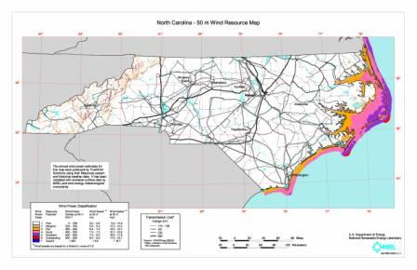

2) The Southeast GAP office also maintains a variety of map layers including modeling of vertebrate distribution and habitat communities. These layers are available for download at their website at http://basic.ncsu.edu/segap/

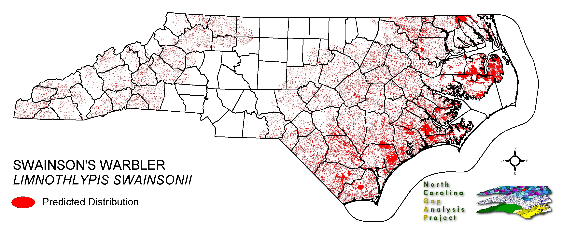

3) The Important Bird Areas Program layer is available from Audubon North Carolina.

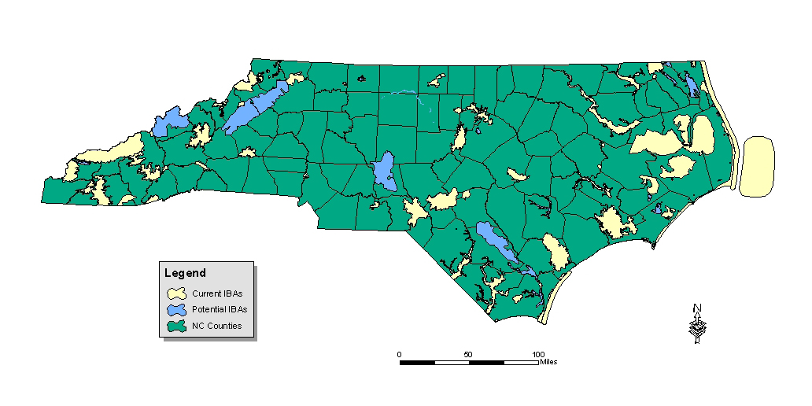

Interactive, Web-based Mapping Resources

Many of the layers represented above are available through interactive mapping resources on-line if in-house GIS resources are not available.

1) Most of the NC One Mapping layers referenced above are used and available at the NC One Naturally Conservision Decision Tool. This is available at the One NC Naturally website at http://www.conservision-nc.net.

2) The Southeast Gap Office also offers an interactive mapping tool that uses predictive models for conservation priority species. This mapping tool allows users to define areas of interest or download their own project area layer. You may select individual species or groups of species to generate species richness models.
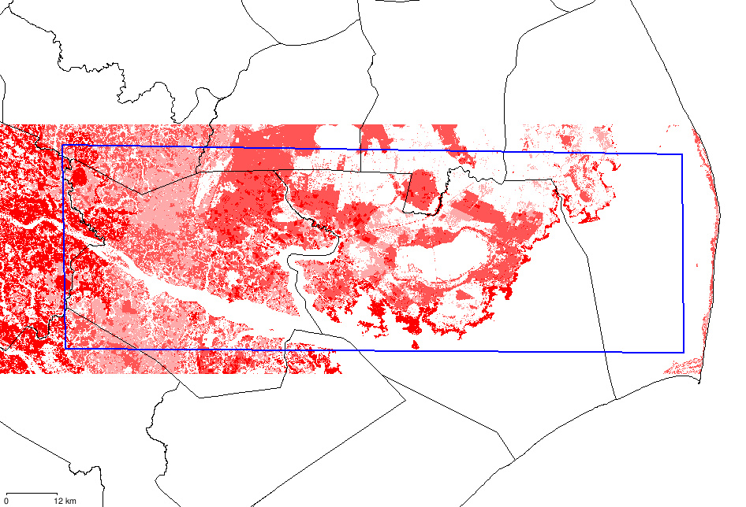

NC Gap map generated 2/29/08

The map above is an example of the model generated for southern Hyde and Beaufort Counties for a group of conservation priority raptors including American Kestrel, Northern Harrier and Barn Owl, all of which are associated with open habitats and farm fields – areas likely to be considered for wind development.

Contrast this with the following map for Kentucky Warbler, Louisiana Waterthrush, Swainson’s Warbler, Worm-eating Warbler, and Prairie Warbler. These species are associated with pocosin and floodplain forest habitats, a much rarer habitat type in this area.

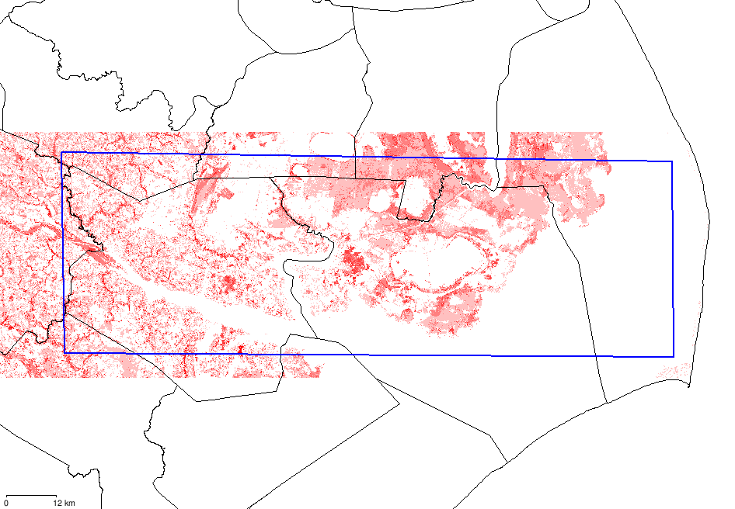

NC GAP map generated 2/29/08

3) Another important interactive tool can be found at the US Department of Defense’s Aircraft Hazard Advisory System (AHAS) and Bird Avoidance Model (BAM). Both of these interactive mapping tools are available at http://www.usahas.com. The difference between the two is important in that AHAS is used in real time, usually for pilots on the day of their flight for a predictive indicator of bird usage of an area. The BAM data are a synthesis of existing bird data from a variety of sources that predicts the relative density of large targets during any period of the year. Another excellent feature of this data is the ability to also map any Military Operations Area (MOA) or Flight Route (both VIR and ) in the area of interest.

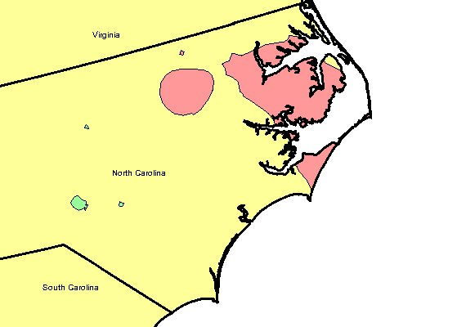
BAM Model for 1st week of March generated March 4, 2008
Red = high number of targets; yellow = moderate; green = low

4) For an even broader range of possibilities use the National Atlas at www.nationalatlas.gov. Here there are a variety of links for biological data on birds, habitats, and many, many others.

Static Maps and Keys for Bird Data

With most bird specific data sets (Breeding Bird Survey, Christmas Counts, etc) it is important to know the locations names, codes, etc for specific sites to be able to drill down to specific data. This section will look at some static maps of locations for bird data, the links to the actual data search engines, and a key for most locations.

- Breeding Bird Surveys data available at http://www.mbr-pwrc.usgs.gov/bbs/bbs.html

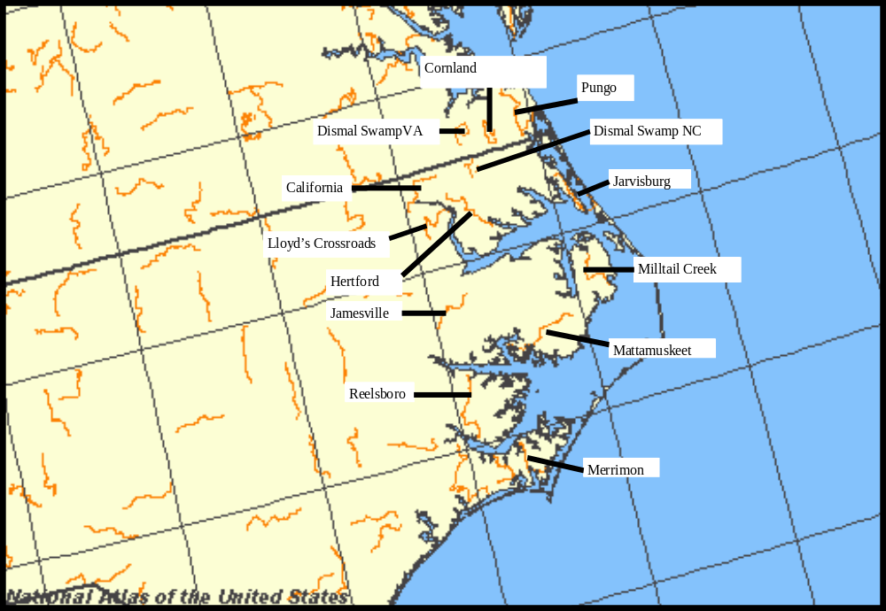

Breeding Bird Survey Routes | Route Number
Dismal Swamp | 63905
California | 63023
Hertford | 63230
Lloyd's Crossroads | 63223
Jamesville | 63109
Mattamuskeet | 63208
Milltail Creek | 63107
Reelsboro | 63108
Merrimon | 63002
Jarvisburg | 63229
Dismal Swamp, VA | 88918
Cornland, VA | 88046
Pungo, VA | 88048

2) Christmas Bird Counts – Historical Data at http://birds.audubon.org/historical-results

Christmas Bird Count Circles | Circle Abbreviation
Kitty Hawk | NCKH
Pettigrew | NCPE
Alligator River  Lake Mattamuskeet | NCAR  NCLM
Bodie/Pea Island | NCBP
Cape Hatteras | NCCH
Ocracoke Island | NCOI
Portsmouth Island | NCPI
Morehead City | NCMC
New Bern | NCNB
Pamlico County | NCPC
Central Beaufort County | NCCB

3) Mid-winter Waterfowl Surveys data available at http://samigbird.fws.gov/
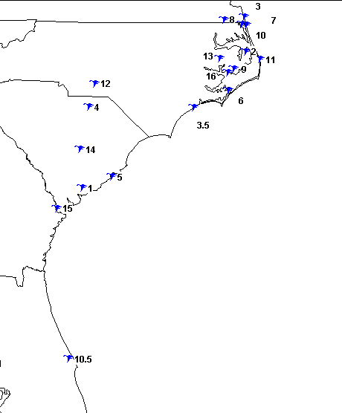
Mid-winter Waterfowl Survey Areas | Site Number
Alligator River National Wildlife Refuge | 2
Cedar Island National Wildlife Refuge | 6
Currituck National Wildlife Refuge | 7
Dismal Swamp National Wildlife Refuge | 8
Lake Mattamuskeet National Wildlife Refuge | 9
Mackays Island National Wildlife Refuge | 10
Pea Island National Wildlife Refuge | 11
Pocosin Lakes National Wildlife Refuge | 13
Swanquarter National Wildlife Refuge | 16

4) Shorebird Monitoring Network data available at http://samigbird.fws.gov/
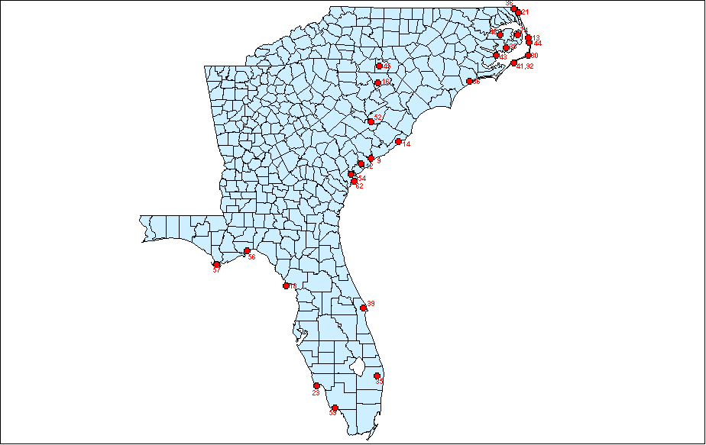
Shorebird Survey Sites | Site Survey Number
Cape Hatteras National Seashore-Bodie Island | 13
Currituck National Wildlife Refuge | 21
Cape Hatteras National Seashore Hatteras Island | 30
Mackays Island National Wildlife Refuge | 36
Lake Mattamuskeet National Wildlife Refuge | 38
Cape Hatteras National Seashore - Ocracoke | 41, 92
Pamlico Point | 43
Pea Island National Wildlife Refuge | 44
Pocosin Lakes National Wildlife Refuge | 48
Alligator River National Wildlife Refuge | 74
Camp LeJeune | 86

Tower Locations – Birds often encounter other hazards and the maps generated at http://www.towerkill.com/reports/US/NC.html#start can provide a visual representation of other obstructions in the area of interest.

Additional References

1) The North Carolina Natural Heritage Program conducts county inventories for significant natural areas, natural communities, and priority species. These county inventories are available from the Natural Heritage Program, and few of the executive summaries are available on-line at http://www.ncnhp.org/. Currently, summaries are on-line for Currituck, Beaufort, Pamlico, and Washington Counties. Inventories are complete for Carteret, Camden, and Pasquotank but are not on-line, and Tyrell and Dare Counties have not had inventories completed to date (early 2008). Completed inventories will provide lists of priority habitats and species found during the inventory process and are a good narrative to go along with mapping data discussed above. Completed inventories may be ordered from the Natural Heritage Program for a small fee.

2) The North Carolina Wildlife Resources Commission (WRC) maintains the NC Colonial Waterbird Database. This biannual effort visits known sites and searches for new sites within the coastal plain for both beach nesting colonial species and inland heronries. Contact the NC WRC for specific location data or to query the PAWS database.

3) Searchable records of the archives of the Chat, the publication of the Carolina Bird Club. Available on-line at http://www.carolinabirdclub.org/chat/database.html

