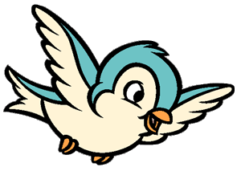
NATURE TOTS and
AUDUBON ACADEMY SCHEDULE
2020-2021

Nature Tots for Spring 2021
Thursdays from 9:30 to 10:45 a.m. Dates and topics are subject to change.
January 2021:
January 21 Objects in the Sky
January 28 Animals in winter
February 2021
February 4 Hibernation vs Migration February 11 Properties of Matter February 18 Forces
February 25 *No Class*

March 2021
March 4 My Plate: Fruits
March 11 My Plate: Veggies
March 18 My Plate: Grains Group
March 25 My Plate: Dairy Group

April 2021
April 1 Butterflies
April 8 *No Class*
April 15 All about seeds
April 22 Caring for our earth
April 29 Insects

May 2021
May 6 What plants need (Rodale)
May 13 Planting a garden
May 20 All about Birds & Worms
May 27 Oceans and Beaches

Audubon Academy
9 a.m. to 1 p.m.
Home School will be the fourth Wednesday unless noted in schedule. Dates and topics are subject to change.
- September 30: Getting to Know Birds, Part I
- October 28: Getting to Know Birds, Part II
- November 18: At Home in a Habitat
- December 16: Let’s Change Climate Change
- January 27 : Sharing our Shores: Beach birds, bees, bats, and other pollinators
- February 24 : Live Cycles of Birds
- March 31: Birds on the Move: Flight & Migration
- April 28: Earth Conservation and Stewardship
- May 19: Water and Water Science

